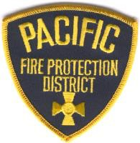
Pacific Fire Protection District
910 West Osage Street Pacific, MO 63069
Phone: (636) 257-3633

ITEMS THAT NEED TO BE TURNED IN TO FIRE DISTRICT

- Completed Fire District Application
- Copy of Current Driver’s License
- US Citizenship Document
- Missouri Firefighter I & II through the Missouri Division of Fire Safety
- Copy of EMT and CPR Certifications
- Résumé
- High School Diploma, or GED
- The Missouri State Highway Patrol Fingerprint Criminal Record Check
- Physician’s Certification

Applications and Job Description/Benefit Information Packets may be found on our website www.pacificfire.org or picked up at the Fire District’s Administration Office, Monday through Friday, 7:30 a.m. until 3:00 p.m. For more information contact our office at 636-257-3633.

Applications will be accepted until 1:00 p.m., Monday, February 26, 2024 at the Fire District’s Administration Office, 910 West Osage, Pacific, Missouri 63069.

Applicants must be 18 years of age.

Applicants are considered for all positions without regard to race, color, religion, sex, national origin, age, veteran status, or disability.

